CI& CD Sample project setup on tomcat server using jenkins

Prerequirements: Tomcat server and jenkins insrtallation on 2 different ec2 insttances

Install Jenkins on AWS EC2
Jenkins is a self-contained Java-based program, ready to run out-of-the-box, with packages for Windows, Mac OS X and other Unix-like operating systems. As an extensible automation server, Jenkins can be used as a simple CI server or turned into the continuous delivery hub for any project.
Step 1:

Prerequisites:
- EC2 Amazon Linux Instance
  - With Internet Access
  - Security Group with Port 8080 open for internet
- Java v1.8.x

Install Java
We will be using open java for our demo, Get latest version from http://openjdk.java.net/install/
yum install java-1.8*
yum -y install java-1.8.0-openjdk

Confirm Java Version:
Lets install java and set the java home
java -version
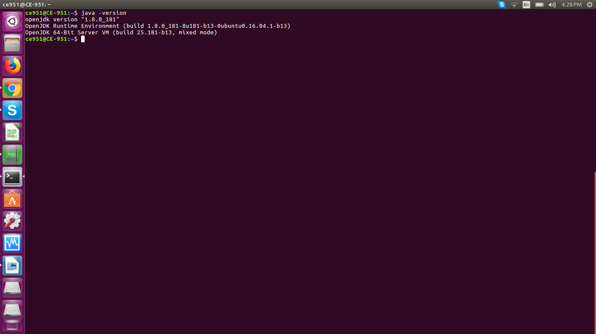

Step 2:

Find the java where its insttalled set permanently /etc/profile configuration file

find /usr/lib/jvm/java-1.8* | head -n 3
JAVA_HOME=
export JAVA_HOME
PATH=$PATH:$JAVA_HOME
To set it permanently update your .bash_profile or /etc/profile
source ~/.bash_profile
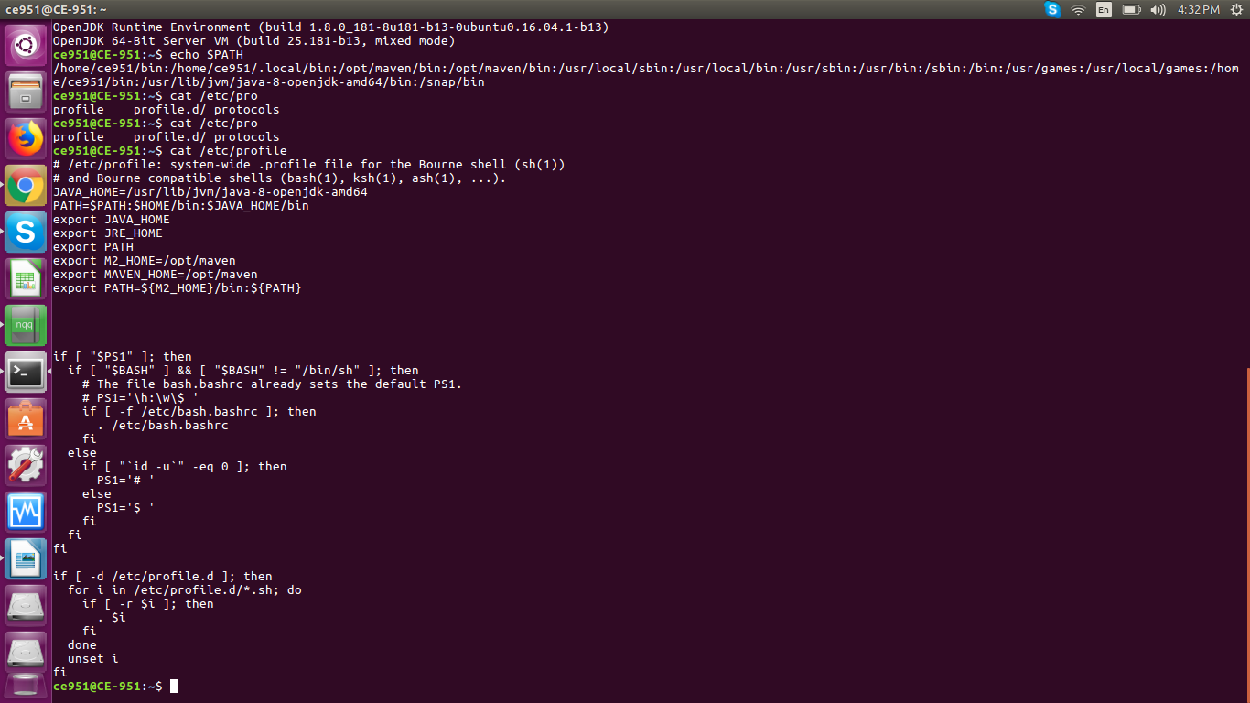
The output should be something like this,
[root@~]# java -version
openjdk version "1.8.0_151"
OpenJDK Runtime Environment (build 1.8.0_151-b12)
OpenJDK 64-Bit Server VM (build 25.151-b12, mixed mode)
Step 3:

Install Jenkins
You can install jenkins using the rpm or by setting up the repo. We will setup the repo so that we can update it easily in future. Get latest version of jenkins from https://pkg.jenkins.io/redhat-stable/
yum -y install wget
wget -O /etc/yum.repos.d/jenkins.repo https://pkg.jenkins.io/redhat-stable/jenkins.repo
rpm --import https://pkg.jenkins.io/redhat-stable/jenkins.io.key
yum -y install jenkins

Start Jenkins using below command:

Start jenkins service
systemctl start jenkins

Setup Jenkins to start at boot,
systemctl enable jenkins

Accessing Jenkins
By default jenkins runs at port 8080, You can access jenkins at
http://serverip:8080

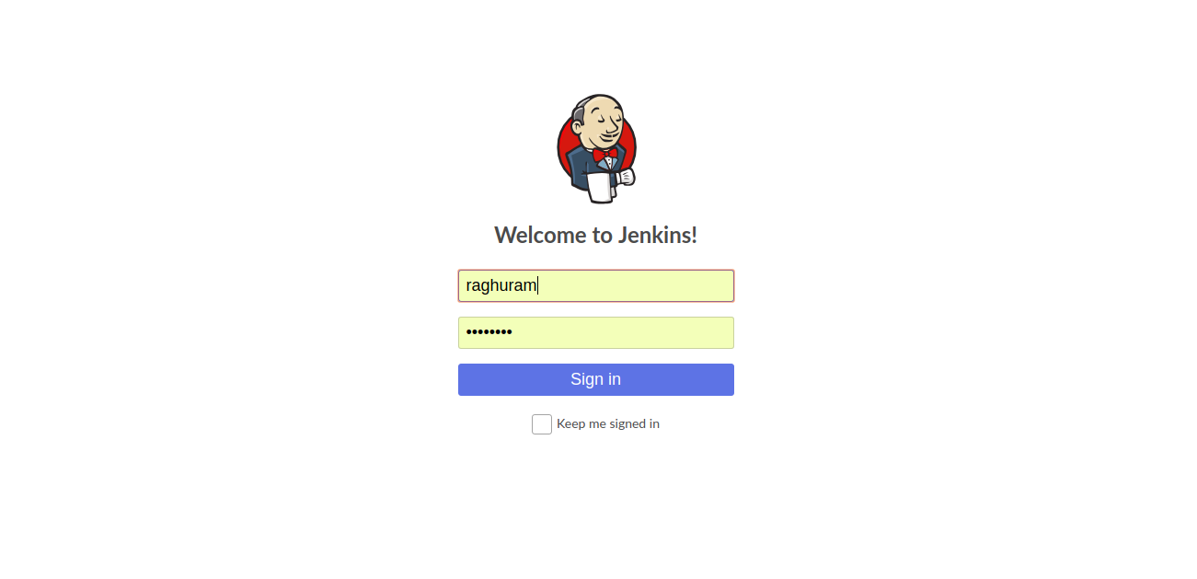

Tomcat setup on EC2 instance:
step:1
Download requried tomcat version from the below link
http://tomcat.apache.org/
http://mirrors.fibergrid.in/apache/tomcat/tomcat-8/v8.5.34/bin/apache-tomcat-8.5.34.tar.gz

Downlod tar file in /opt folder and extract the download file in using below command
sudo tar -xvzf apache-tomcat-8.5.34.tar.gz

drwxr-xr-x 9 root root 4096 Oct 1 15:46 apache-tomcat-8.5.34/
start tomcat using below commmand
ce951@CE-951:/opt$ sudo ./apache-tomcat-8.5.34/bin/startup.sh
Using CATALINA_BASE: /opt/apache-tomcat-8.5.34
Using CATALINA_HOME: /opt/apache-tomcat-8.5.34
Using CATALINA_TMPDIR: /opt/apache-tomcat-8.5.34/temp
Using JRE_HOME: /usr
Using CLASSPATH: /opt/apache-tomcat-8.5.34/bin/bootstrap.jar:/opt/apache-tomcat-8.5.34/bin/tomcat-juli.jar
Tomcat started.

To shutdown tomcat usinng below command
ce951@CE-951:/opt$ sudo ./apache-tomcat-8.5.34/bin/shutdown.sh
Using CATALINA_BASE: /opt/apache-tomcat-8.5.34
Using CATALINA_HOME: /opt/apache-tomcat-8.5.34
Using CATALINA_TMPDIR: /opt/apache-tomcat-8.5.34/temp
Using JRE_HOME: /usr
Using CLASSPATH: /opt/apache-tomcat-8.5.34/bin/bootstrap.jar:/opt/apache-tomcat-8.5.34/bin/tomcat-juli.jar

Download java and find where it is setup java home path in /etc/profile
JAVA_HOME=/usr/lib/jvm/java-8-openjdk-amd64/
PATH=$PATH:$HOME/bin:$JAVA_HOME/bin
export JAVA_HOME
export JRE_HOME
export PATH

After setting up tomcat and jenkins and java installation setup a sample project in jenkins

